Form No. 40-263: For Reporting Year (RY) 2025
Raw Data – Ancillary Report Tab
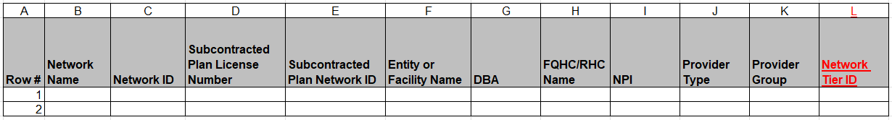
Continuation:
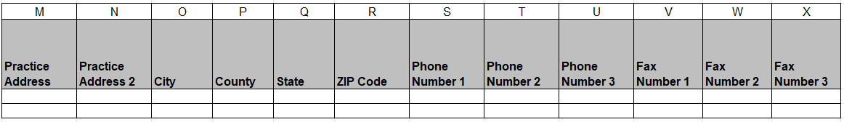
Continuation:
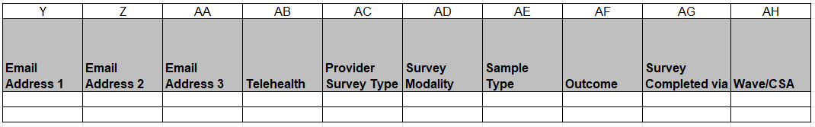
Continuation:
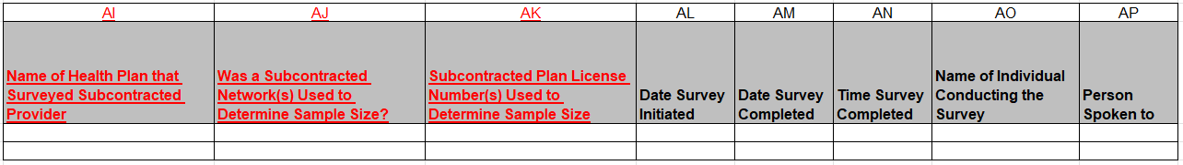
Continuation:
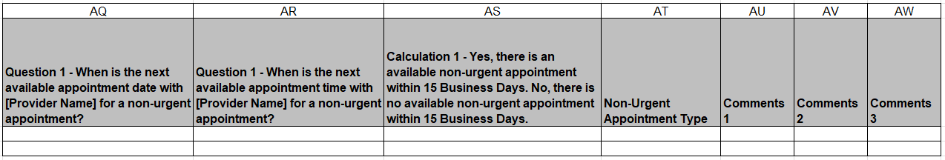
Summary of Changes:
Raw Data – Ancillary Report Tab
Excel Column Reference | RY 2025 TA Report Form Heading | Action
L | Network Tier ID | Added Field and Field Instructions
M | Practice Address | Updated Field Instructions
AI | Name of Health Plan that Surveyed Subcontracted Provider | Added Field and Field Instructions
AJ | Was a Subcontracted Network(s) Used to Determine Sample Size? | Added Field and Field Instructions
AK | Subcontracted Plan License Number(s) Used to Determine Sample Size | Added Field and Field Instructions
T | Non-Urgent Appointment Type | Updated Field Instructions

