Form No. 40-267: For Reporting Year (RY) 2024
Specialist Report Tab
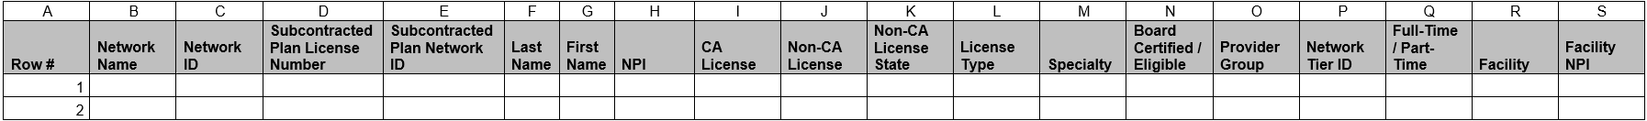
Continuation:
Summary of Changes:
Specialist Report Tab
Excel Column Reference | RY 2024 ANR Report Form Heading | Action
P | Network Tier ID | Updated Field Instructions
AH | In-Person Appointments | Updated Field Instructions

Form No. 40-267: For Reporting Year (RY) 2024
Specialist Non-Physician Medical Practitioner (NPMP) Report Tab
Continuation:
Summary of Changes:
Specialist Non-Physician Medical Practitioner (NPMP) Report Tab
Excel Column Reference | RY 2024 ANR Report Form Heading | Action
O | Network Tier ID | Updated Field Instructions
AD | In-Person Appointments | Updated Field Instructions

